- Search for S3 in the Search Bar
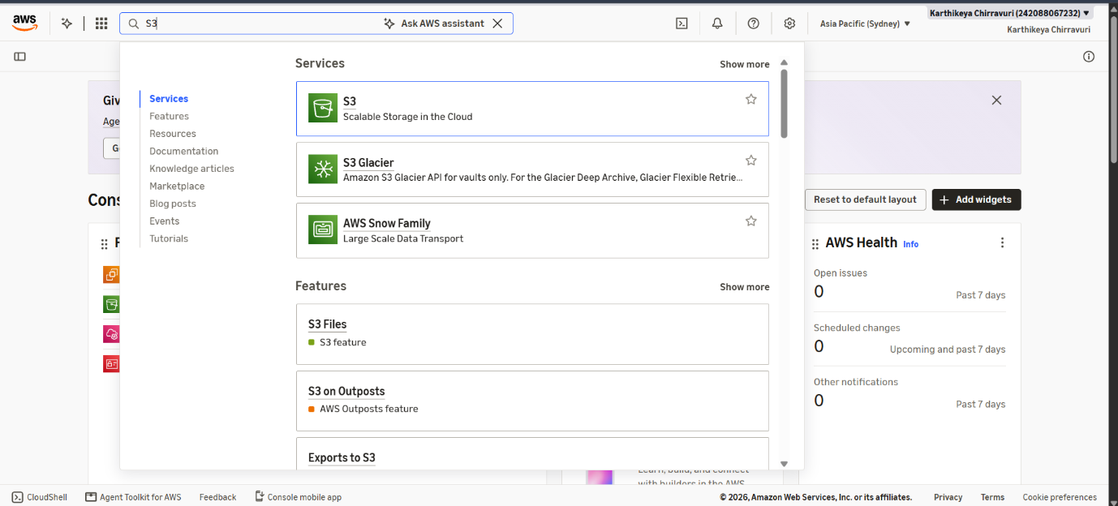

2) Click Create a Bucket and name it
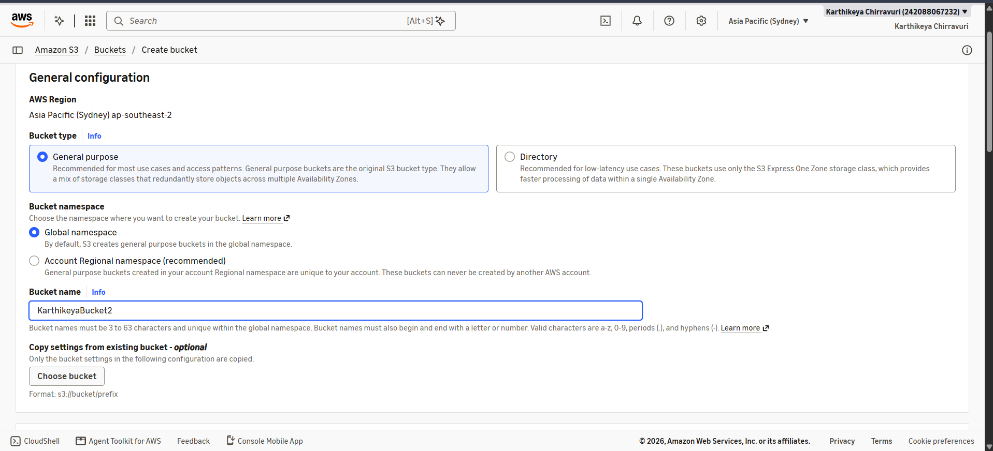

3) Scroll down and enable Bucket Versioning
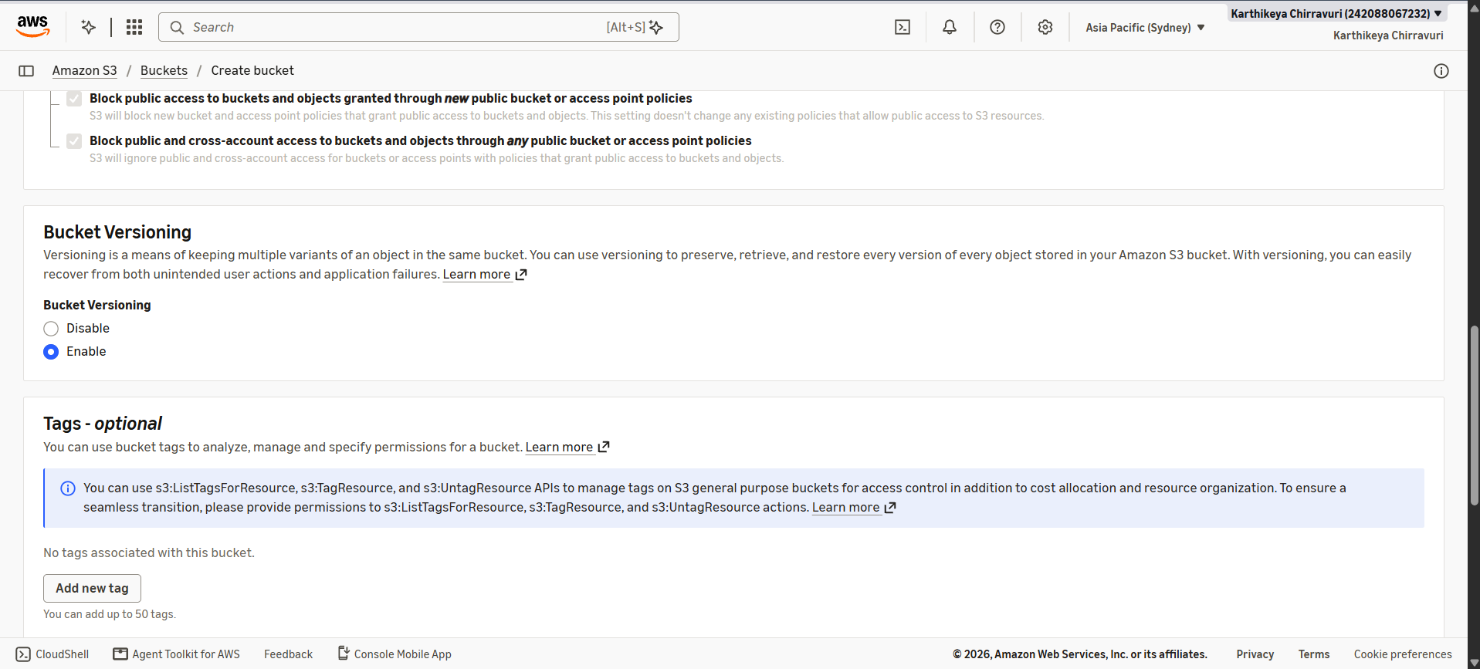

4) Click on Create bucket
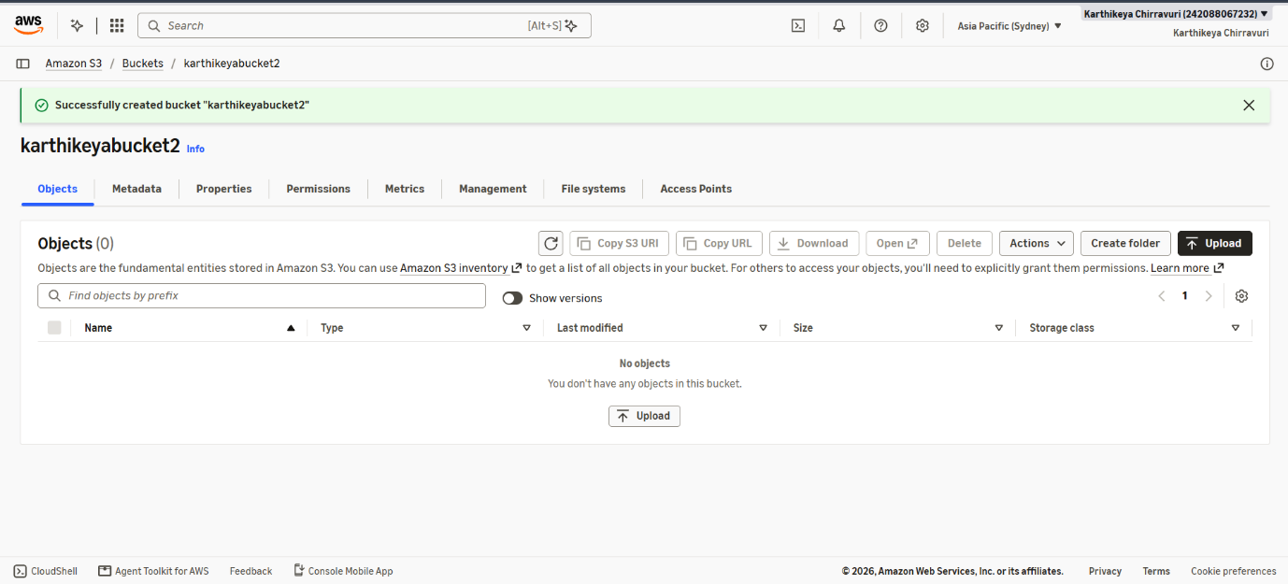

5) Upload a Custom Text File
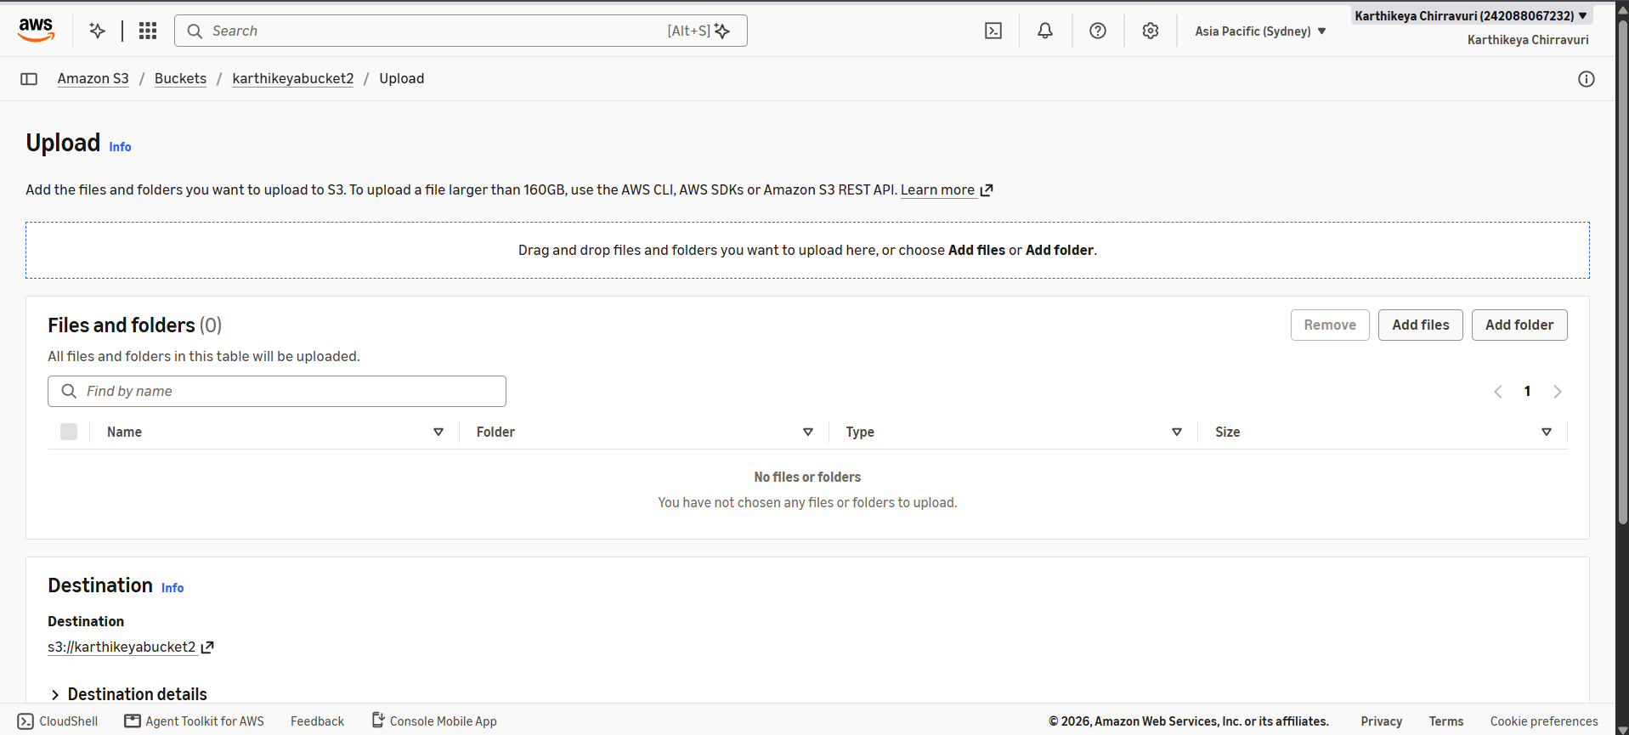

6) The text file should contain “ This is Version 1”. Then click upload
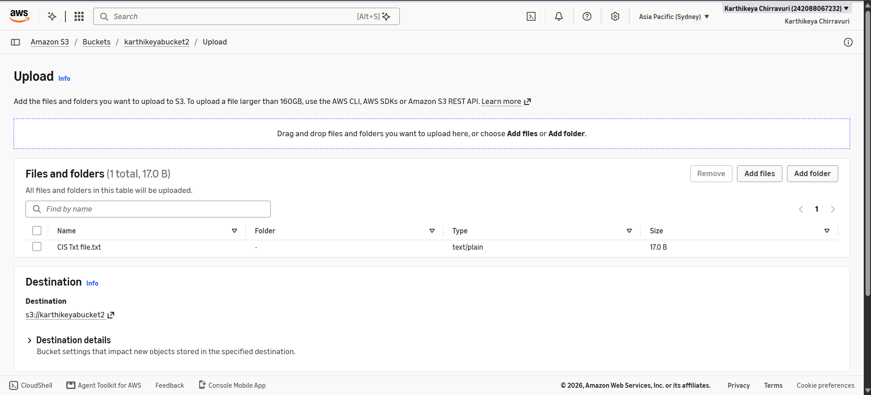

7) File is uploaded Successfully
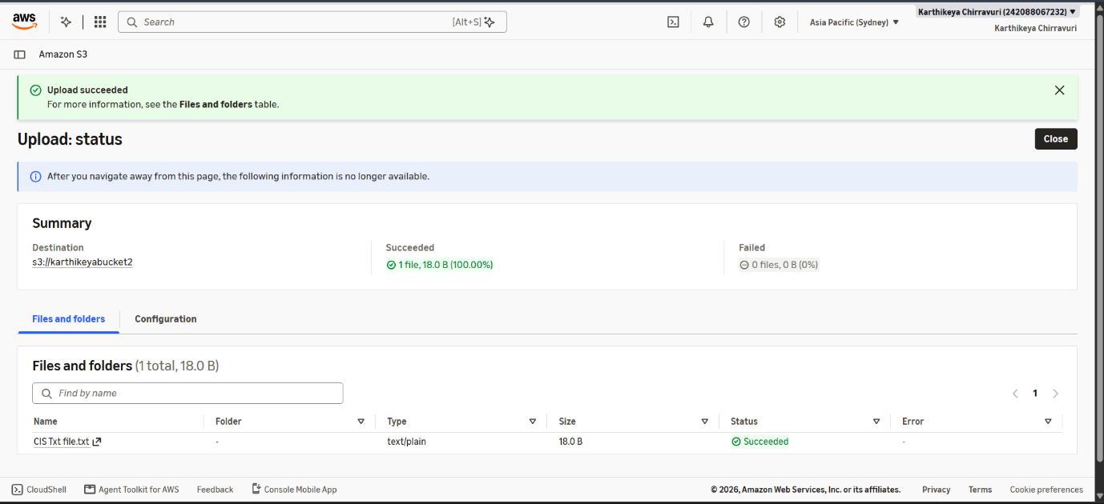

8) Then update the File as “This is Version 2”
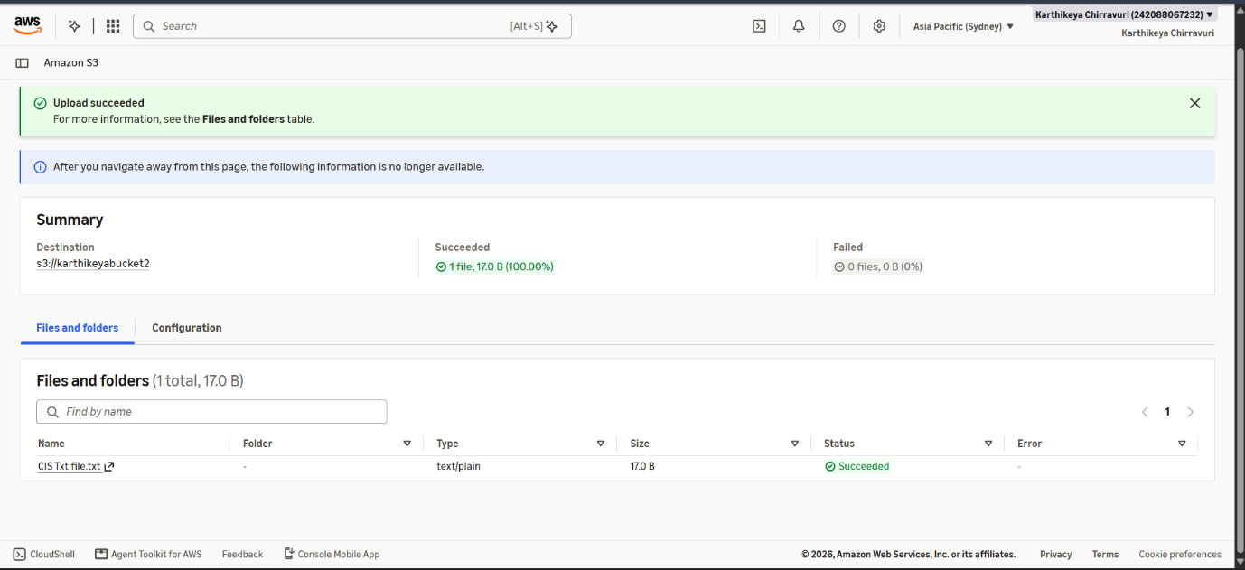

9) After Clicking on upload , Two versions of the same file will show up


